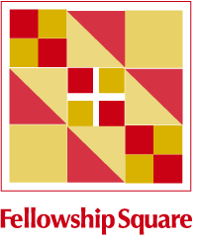
Emergency Preparedness Kits
Help a Low Income Senior in a Time of Emergency
During a major storm or natural disaster our residents are asked to shelter in place by disaster relief officials. In order to make their apartments safer we are collecting items
(and completed kits) to distribute during an emergency.

- Clear Plastic Container (14x8x6- locks securely and can fit under a bed)
- Duct Tape
- Plastic Sheeting or a clear shower curtain
- Rain Poncho
- Manual Can Opener
- 10 Glow sticks
- Hand Sanitizer
- Disinfectant Wipes
- 4-5 Large Garbage Bags
- Paper Towels
- Emergency Radio and Batteries
- Small First Aid Kit

Kits/Items should be delivered to
Fellowship Square
2231 Colts Neck Rd.
Reston, VA 20191

For more information please contact us at 703-860-2536 or fcodding@fellowshipsquare.org

For other was to make a difference in the lives of residents of Fellowship Square, visit our website.
www.fellowshipsquare.org

